Name : Mustafa Senih Topsakal

Date : 11/21/2021

Do :

1. Exercises 8.1 (Q1)

The similarity that they share is that both divide-and-conquer and dynamic programming divide the main problem into sub-problems for the best answer, but they differ in the way of finding the answer. Divide-and-conquer combines the answers from the sub-problems and finds the best possible answer. On the other hand Dynamic uses those answers from the sub-problems to find the other problems answers.

1. Exercises 8.1 (Q2)

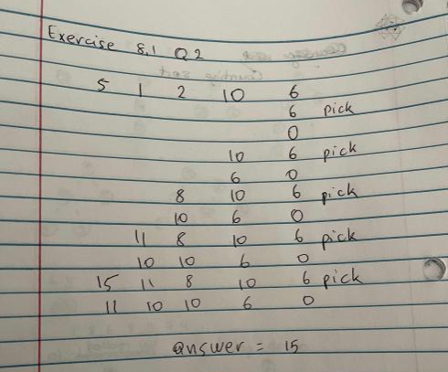

1. Exercises 8.2 (Q1)

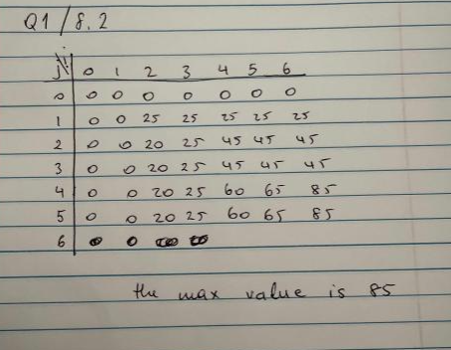

B- There is only one possible subset

C- The knapsack algorithm shows the subset of the possible ones.

1. Apply of Warshall’s algorithm to the digraph shown

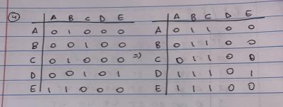

1. Apply Floyd’s algorithm to the digraph shown

